**Introduction**

The purpose of this document is to specify the hardware and software requirements of the Fotoball project. The project was derived with the idea that camera technology could be much further woven into the fabric of sports, specifically football, than it currently is.

The most recent camera upgrades to the way games are broadcast involve “skycams” where a camera is suspended by a series of cables above the field and remotely controlled to provide a bird’s eye view of the action. There have also been brief experiments involving “helmet cams” where a small camera is mounted to a player’s helmet to provide first-hand game action. After some research, it was realized that very little has been done involving attaching cameras directly to the football. The only previous attempt of note was a side-mounted camera that takes a still image after each rotation and ultimately pieces together a choppy video that is oriented in the wrong direction.

Our project will involve mounting two cameras to each end of the football to be able to capture a front and rear view of where the football is heading and where it came from. The data captured by each camera will then be wirelessly streamed to a user’s mobile device, most likely a smart phone. From there the video can be saved, edited, and shared however the user chooses.

There are two potential markets of interest for the product. The first is as a recreational device for kids and young adults to be able to film fun videos and share with their friends. Much like the GoPro has revolutionized extreme sports like skiing, surfing, and rock climbing, we feel this product could do the same for football. The second market of interest is in high-level televised NFL and college games. This is more of a challenge since the ball would have to adhere to extremely specific guidelines, but the benefits the fan watching on television could be huge.

**Glossary**

Alpha testing - a simulated or actual operational testing by potential users/customers or an independent test team at the developers' site.

Android - a mobile operating system developed by Google and run on many different devices

C++ - a general-purpose programming language.

GoPro - a compact, often wearable, camera that is popular in the use of filming in extreme situations that would render a traditional camera unfit

iOS - Apple’s mobile operating system run on all Apple mobile devices

Java - an object-oriented programming language that is maintained by Oracle Corporation

Microcontroller

Resolution - the degree of sharpness of a computer-generated image as measured by the number of dots per linear inch in a hard-copy printout or the number of pixels across and down on a display screen.

Serial

**System Evolution**

There are several critical functions that the first iteration of our system must have.

1. The hardware must be attached to the ball in a way that keeps the ball as close to its originally properties as possible. Weight needs to be consistent, the overall shape needs to remain the same, and the ball must remain balanced. There is a certain amount of leeway with which to work, but not a lot. If the ball does not behave and act like a regular football, the rest will be meaningless.
2. The video data must reliably transmit to the user’s mobile device. If a throw is not recorded and becomes “lost” the user will get frustrated and likely stray away from the product. **Internal storage will also be an option to act as a backup should this happen.**
3. The image must be stabilized enough to make the video an acceptable quality. This is perhaps our biggest challenge, and likely why this product does not currently exist. Our system needs to compensate for every movement of the football as it rotates and wobbles, and ultimately return a smooth video.
4. The software will have to be compatible with both Apple and Android devices. To not support one of these platforms would be ignoring too big of a market segment for the endeavor to be worthwhile.

As the system evolves, there are additional features that would fit in nicely. One idea is to add additional sensors capable of measuring the speed, location, rotation, and orientation of the ball. This data could then be extrapolated and used to provide “throw quality” feedback that will tell user how far the ball went, the ball’s velocity, and how tight of a spiral it was.

Another goal is to gradually improve the quality of components to provide higher resolution video and even audio.

**System Models**

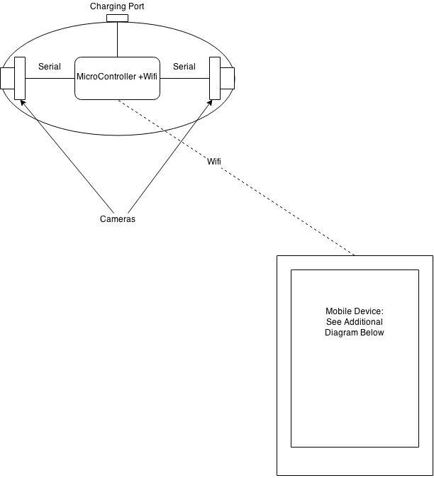

**Constraints**

Time:

Product and code design will be completed by 02/19/2015

Prototype completion will be completed by 03/13/2015

Alpha testing will be completed by 03/26/2015

Testing model will be completed by 04/09/2015

Final test will be completed by 04/16/2015

Final presentation will be completed by 04/23/2015

Hardware:

The microcontroller needs to weigh under 25g.

The microcontroller needs to communicate via Wi-Fi.

The microcontroller needs to store video locally.

The camera needs to weigh under 20g.

The electronics need to be powered for at least 4 hours.

Software:

The mobile application will be programmed in Java.

The firmware will be programmed in C/C++.

**Requirement Specification**

Hardware:

The electronics shall be lightweight.

The electronics shall not affect footballs throw.

The electronics shall be able to transmit data wirelessly.

Security and Safety Requirements

The electronics shall not be accessible by unauthorized device.

Database Requirements

The software shall be able to save video locally.

**Management Issues**

Schedule

|  |  |
| --- | --- |
| **Date** | **Process** |
| February 19 | Product + Coding Design |
| March 13 | Prototype Completion |
| March 26 | Alpha Testing |
| ***April 09*** | ***Testing Model (in class)*** |
| April 16 | Final Test |
| ***April 23*** | ***Presentation of Final Project*** |

Technical Skills

· Hardware expertise

· Coding skills

· App development

During this project we plan to combine all of our skills to construct a unique and engaging product.

**Functional Requirements Definition**

The Fotoball device will be used mainly with these two objectives in mind:

* Recreational purposes .- User will be able to capture, edit and share still images or videos from their mobile devices.
* Live streaming .- The 2 attached cameras to the fotoball device will make the user feel like he/she is part of the action.

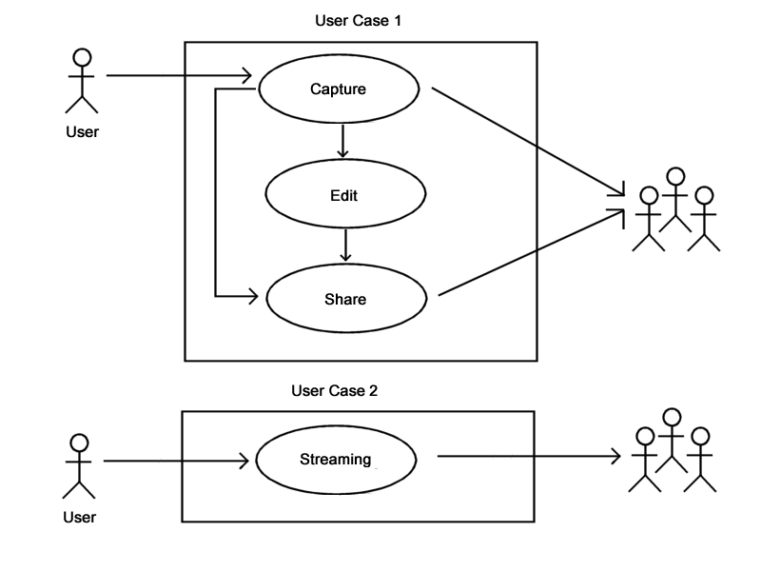

Additional features could be added for training drills purposes, such as gathering information (throwing and rotational speed, tossed angle, etc.), which will help the user to improve his/her "throw quality."

**Disasters**

There are some unfavorable situations we must consider while working on this project.

If we must face any of those circumstances, a backup plan has been elaborated to overcome these issues. We are considering the following scenarios and how we plan to deal with them:

- Not getting all the required hardware on time to construct a high quality product: we have proposed a schedule which will allow us enough time to workaround any issue.

- The image/video streaming to the user's mobile device gets lost or interrupted: an internal storage option will be added as a backup solution.

- The image/video streaming gets too blurred during the action: a real-time digital image stabilization technique will be used to counteract the motion.

